**JMS 302: Hacking the Media**

**Reading Notes, Week 10**

**HTML, Chapters 7 & 13**

**Pine, Chapter 12**

**Core Concepts** (C)

* HTML Forms
  + Basic form controls (and the HTML to generate): text input, text area, radio buttons, checkboxes, drop-down boxes, submit buttons
  + How forms work (name/value pairs)
  + Form tags & attributes: form (action, method, id), input (type, name, maxlength, checked, value), textarea, select (name, size, multiple), option (value, selected), label (for)
* CSS
  + bullet point styles (including images)
  + Table properties: width, padding, text-align, background-color
  + Tips for table styling: padding, headings, alternate rows, aligning numerals
* Ruby
  + Classes we already know: String, Integer, Float, Array, File, Dir. Special objects: true, false, nil
  + Usually use new to get an object from class (but not always—File.open; string, array & number literals)
  + Time class, Time comparison, Time arithmetic
  + Hashes (very important—see Code Academy as well)

**Important Concepts (B)**

* HTML Forms
  + Common form controls (and the HTML to generate): password input, image buttons, file upload, hidden
  + SSL (Secure Sockets Layer)
  + Where to place labels
  + HTML5 form validation (required, date, email & url, search & placeholder
    - But beware: this is still not universally supported
  + 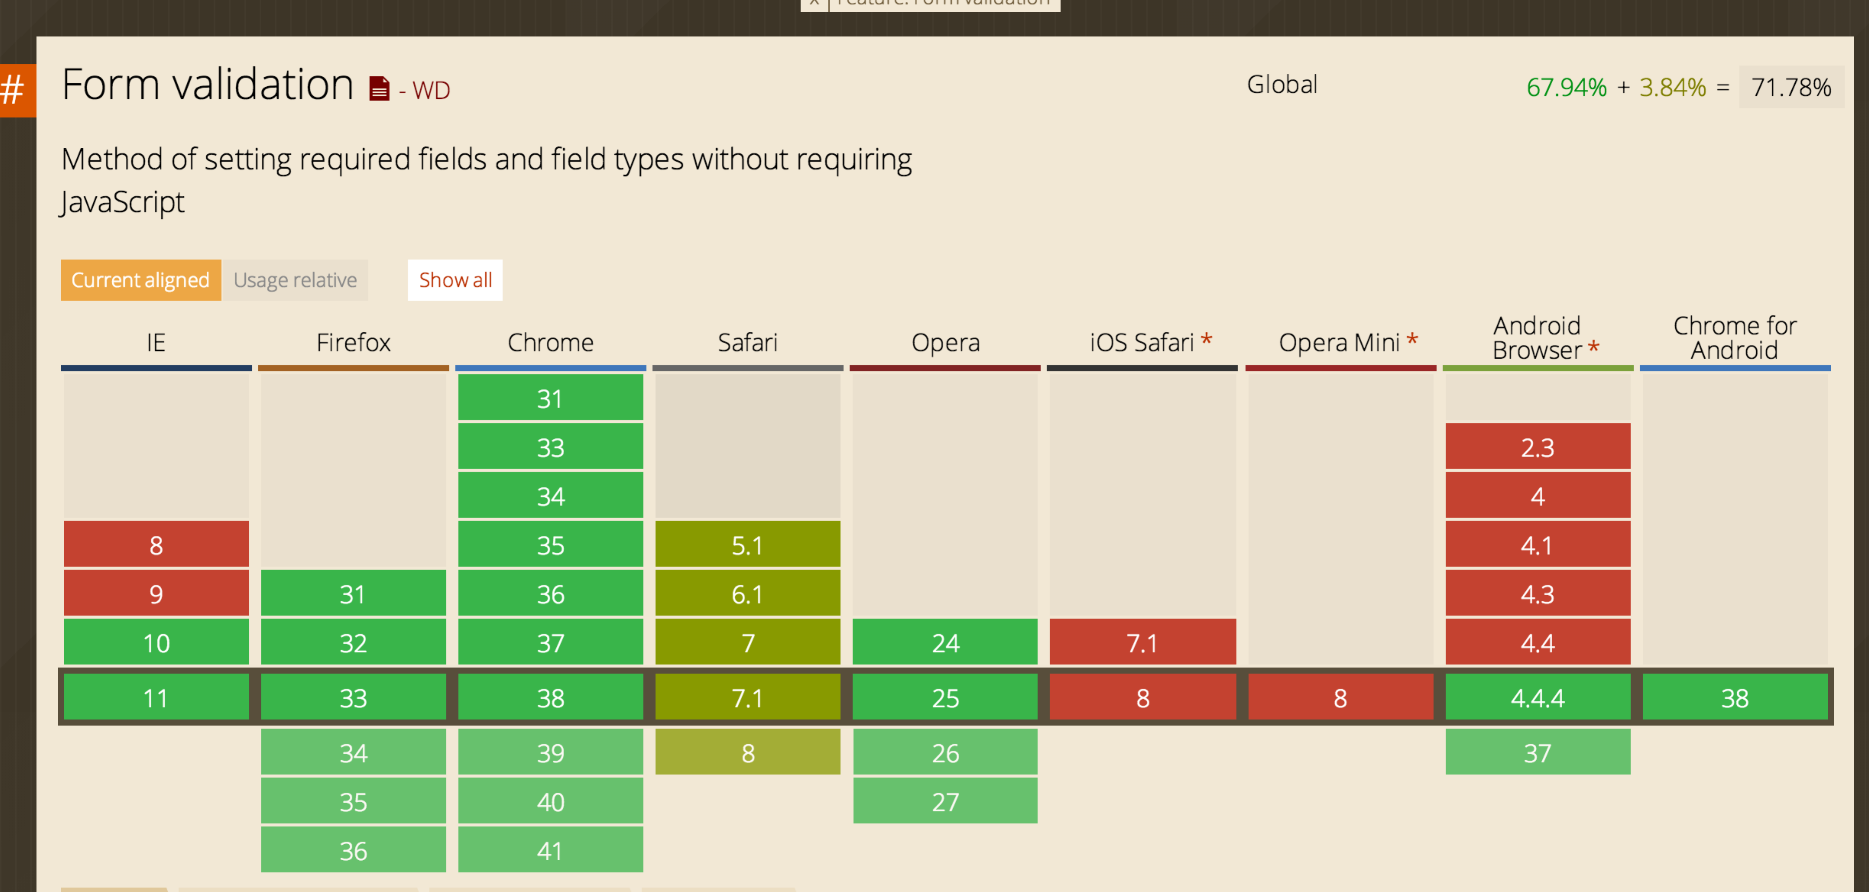
    - <http://caniuse.com/#feat=form-validation>
* CSS
  + Styling text inputs, submit buttons, fieldsets & legends
* Ruby
  + Ranges (note include? method)
  + Strings & array notation (my_string[4], my_string[2..5], my_string[-1], etc.)
  + Note each_line method on page 102. Look at author’s solution to Birthday helper!

**Concepts for Mastery (A)**

* HTML Forms
  + When to use post vs. get method for form submission
  + Fieldset & legend
* CSS
  + Table properties: text-transform, letter-spacing, font-size, :hover
  + Border on empty cells, gaps between cells
  + Aligning form controls

**FYI**

* CSS
  + list-style-position
  + cursor styles
* Ruby
  + Classes and the Class Class
  + Changing existing classes